**FUNCTIONS (PART 2 OVERLOAD,**

**TEMPLATES AND RECURSION)**

**LAB # 7**



**Spring 2022**

**CSE102L Computer Programming Lab**

Submitted by: **Ali Asghar**

Registration No. : **21PWCSE2059**

Class Section: **C**

“On my honor, as student of University of Engineering and Technology, I have neither given nor received unauthorized assistance on this academic work.”

Student Signature: ______________

Submitted to:

**Engr. Abdullah Hamid**

July 4, 2022

Department of Computer Systems Engineering

University of Engineering and Technology, Peshawar

**Lab Objective(s)**

* To understand the programming of recursive functions and overloading functions
* To understand function programming, its types and function-call

**TASK # 1:**

**Title:**

Print your name and registration number 10 times in C++ using recursion.

**CODE SCREENSHOTS:**

Here are the screenshots of the code.

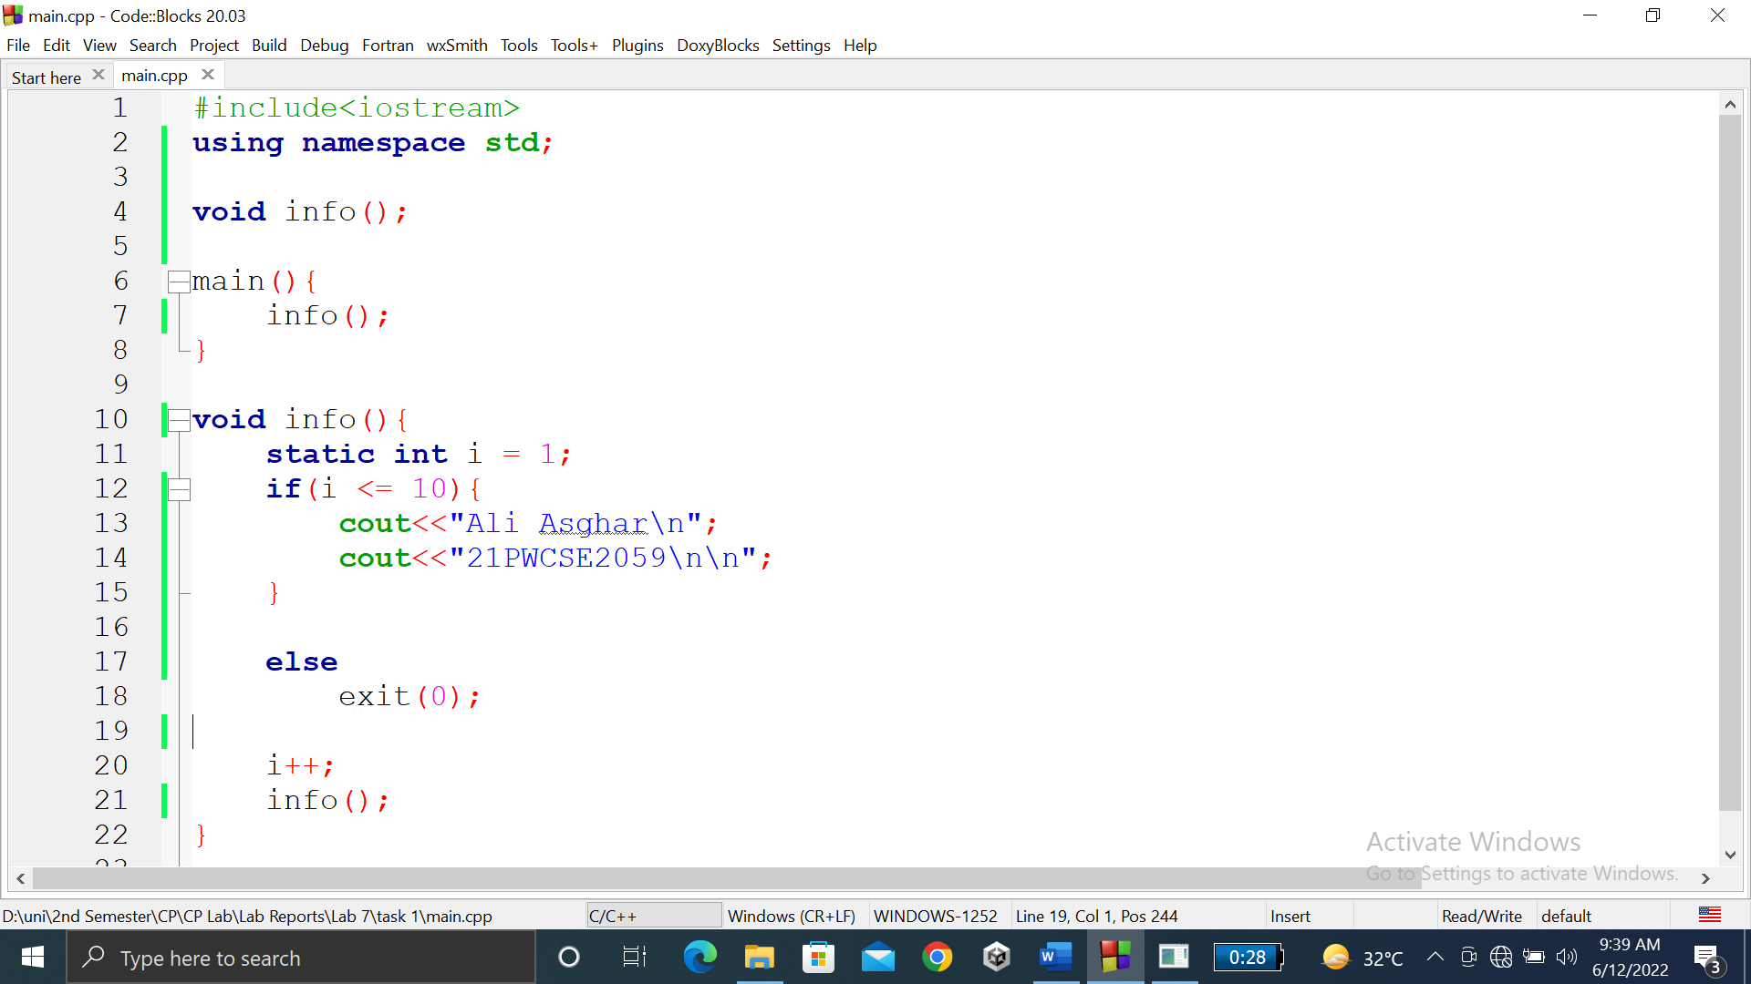

### **OUTPUT (COMPILATION, DEBUGGING & TESTING):**

Here is the screenshot of the output of above code.

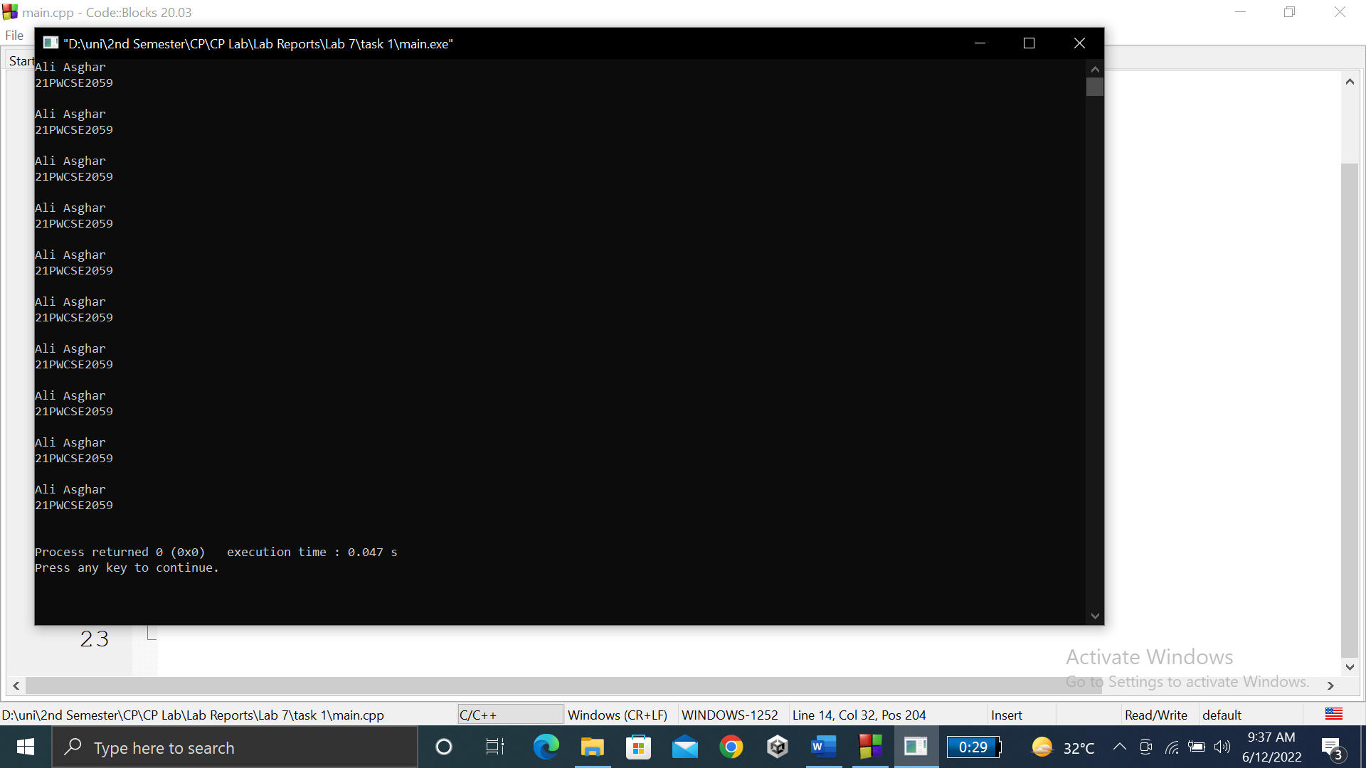

**TASK # 2:**

**Title:**

Write a C++ program where you take two values from……….and calculate their sum. **CODE SCREENSHOTS:**

Here is the screenshot of the code.

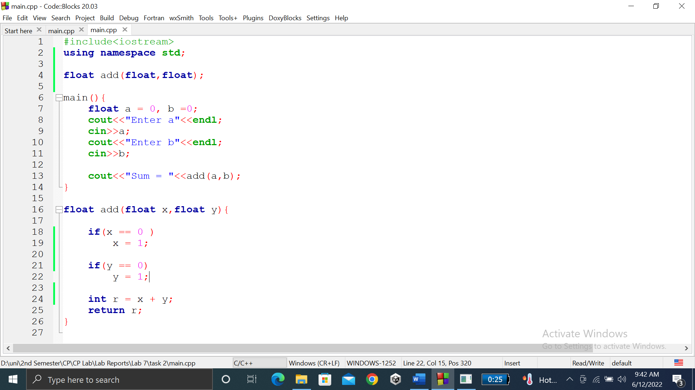

### **OUTPUT (COMPILATION, DEBUGGING & TESTING):**

Here are the screenshots of the output of above code.

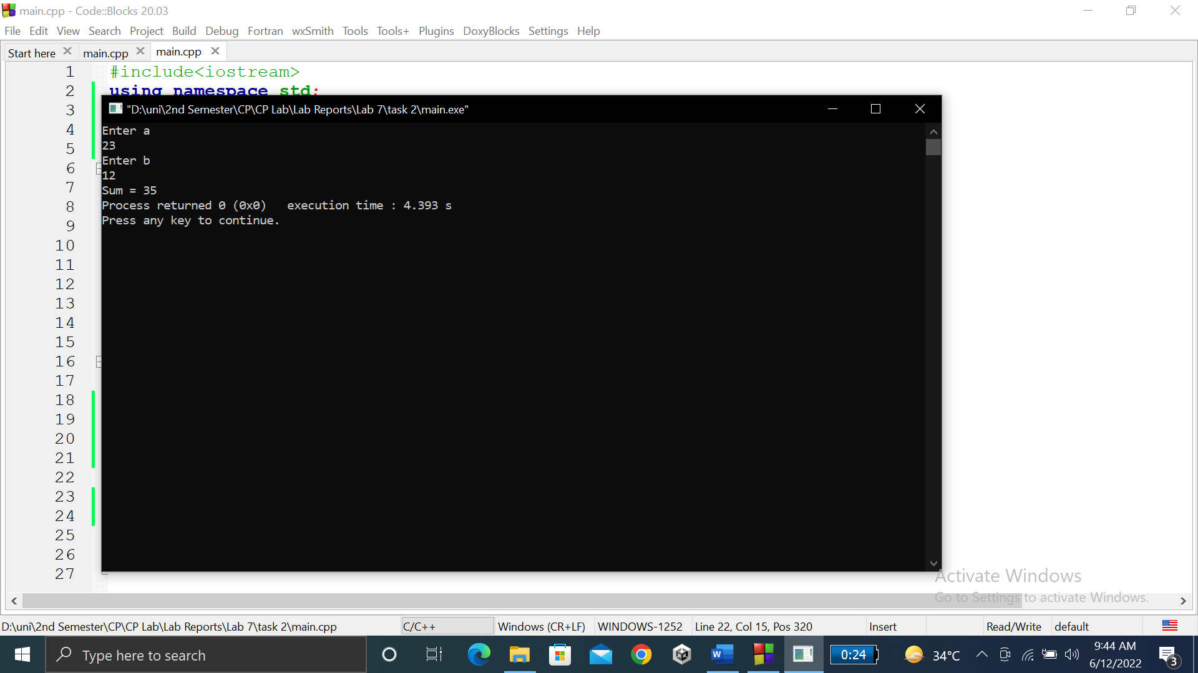

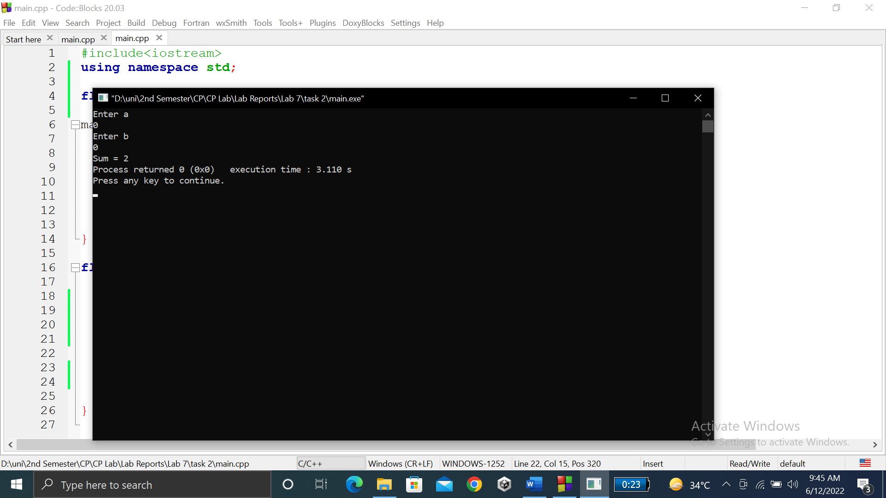

**TASK # 3:**

**Title:**

Write a function to find Sum of N natural numbers using Recursion.

**CODE SCREENSHOTS:**

Here is the screenshot of the code.

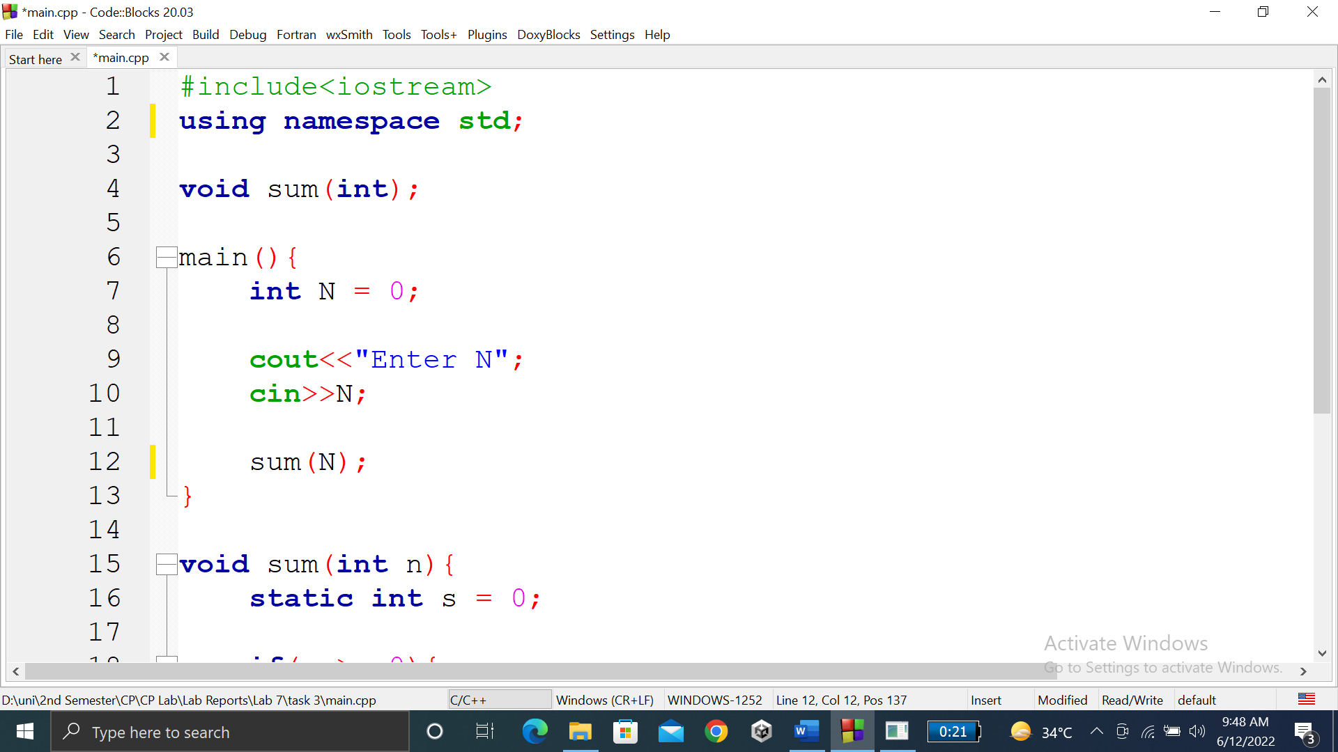

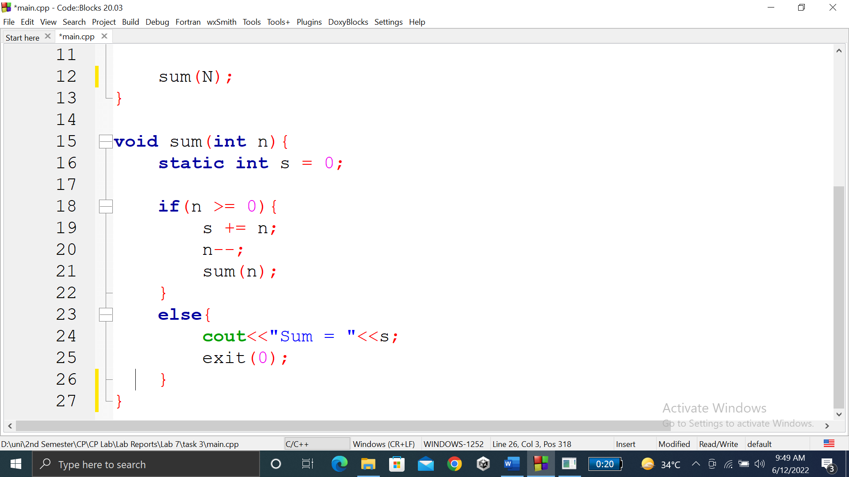

### **OUTPUT (COMPILATION, DEBUGGING & TESTING):**

Here is the screenshot of the output of above code.

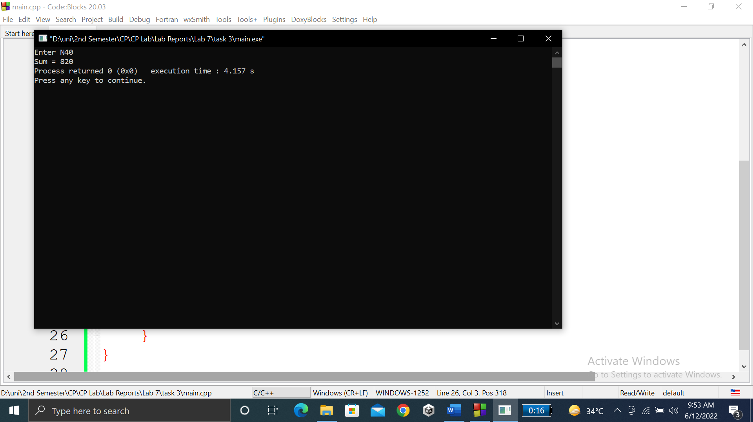

**TASK # 4:**

**Title:**

Calculate the sum of odd natural numbers 1+3+5+7+……………. + n using Recursion….n as input from user.

**CODE SCREENSHOTS:**

Here is the screenshot of the code.

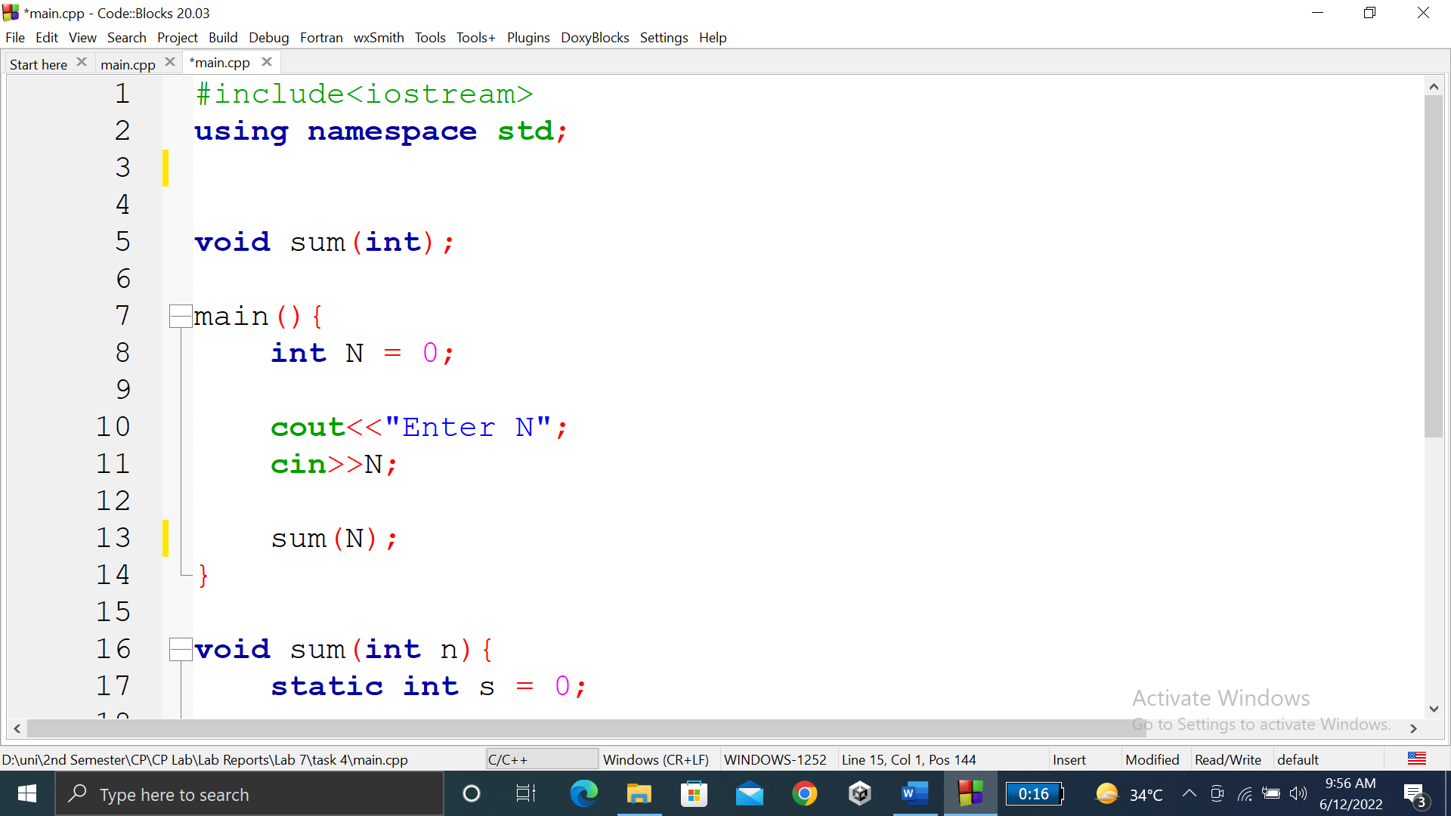

### **OUTPUT (COMPILATION, DEBUGGING & TESTING):**

Here is the screenshot of the output of above code.

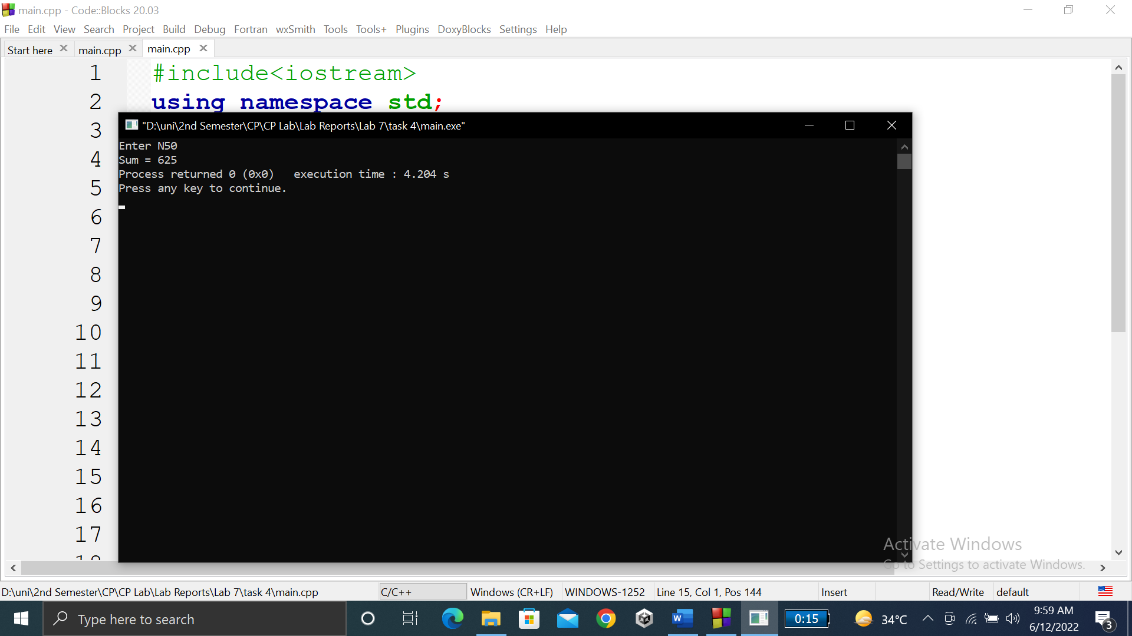

**TASK # 5:**

**Title:**

Overload three functions with name “grade”……………... Consider total marks = 150.

**CODE SCREENSHOTS:**

Here are the screenshots of the code.

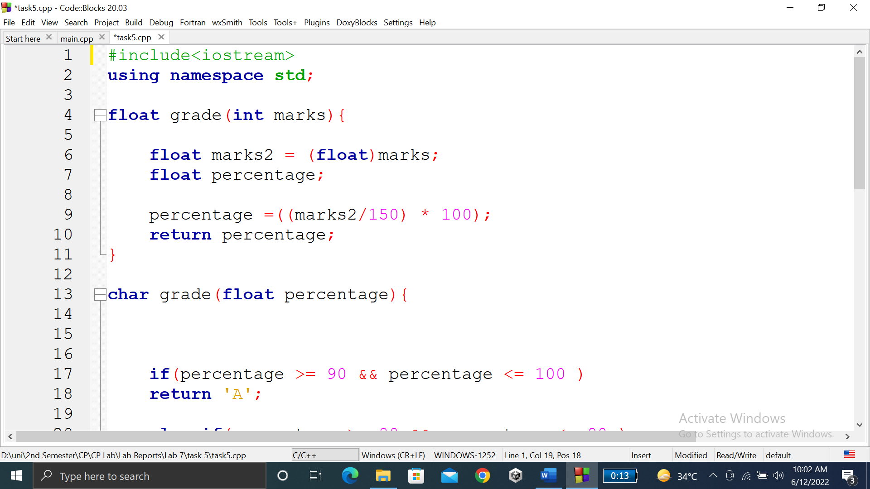

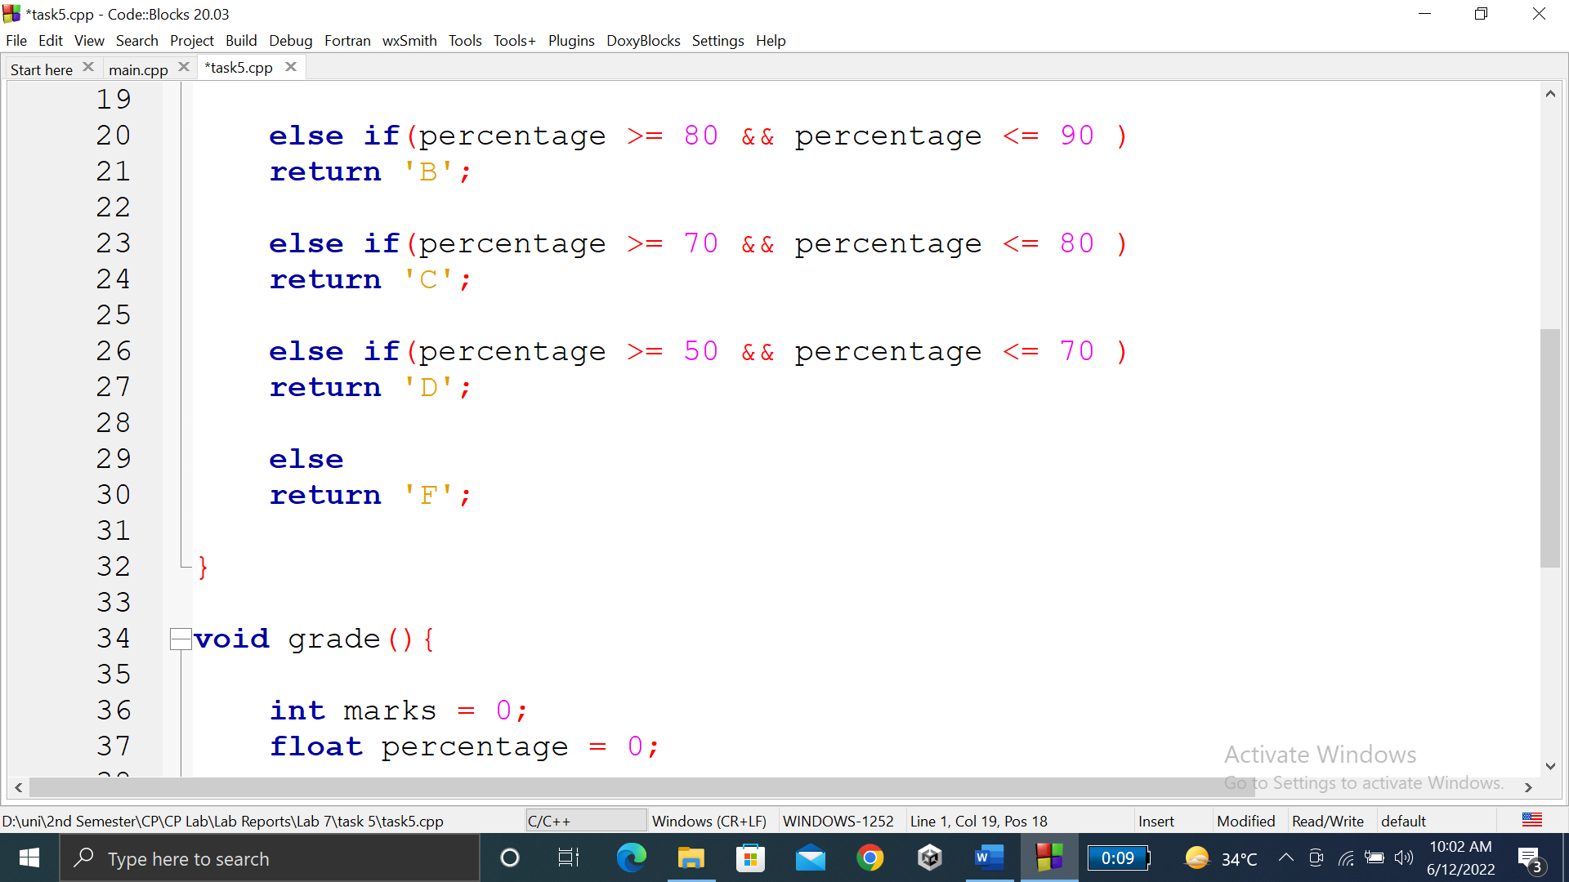

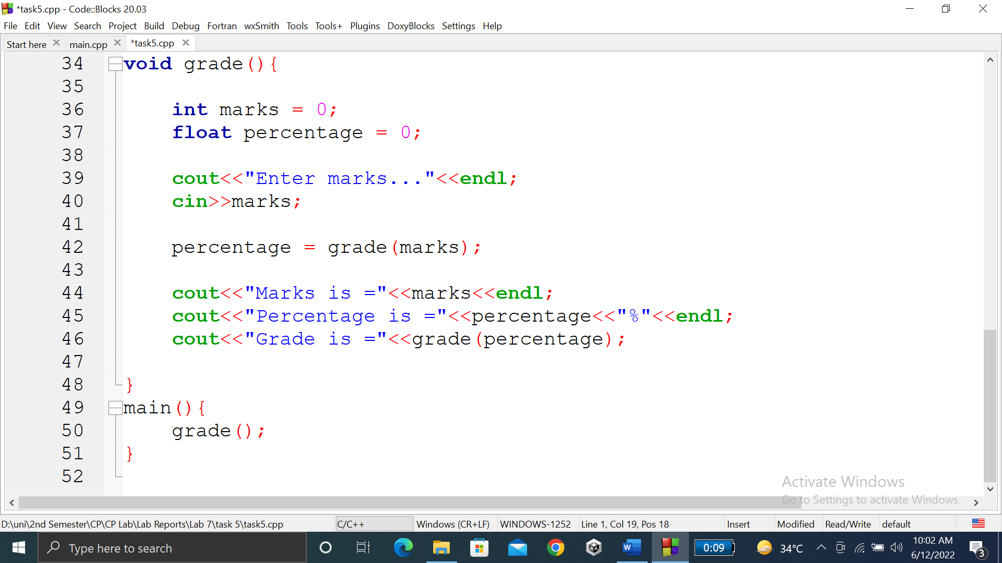

### **OUTPUT (COMPILATION, DEBUGGING & TESTING):**

Here is the screenshot of the output of above code.

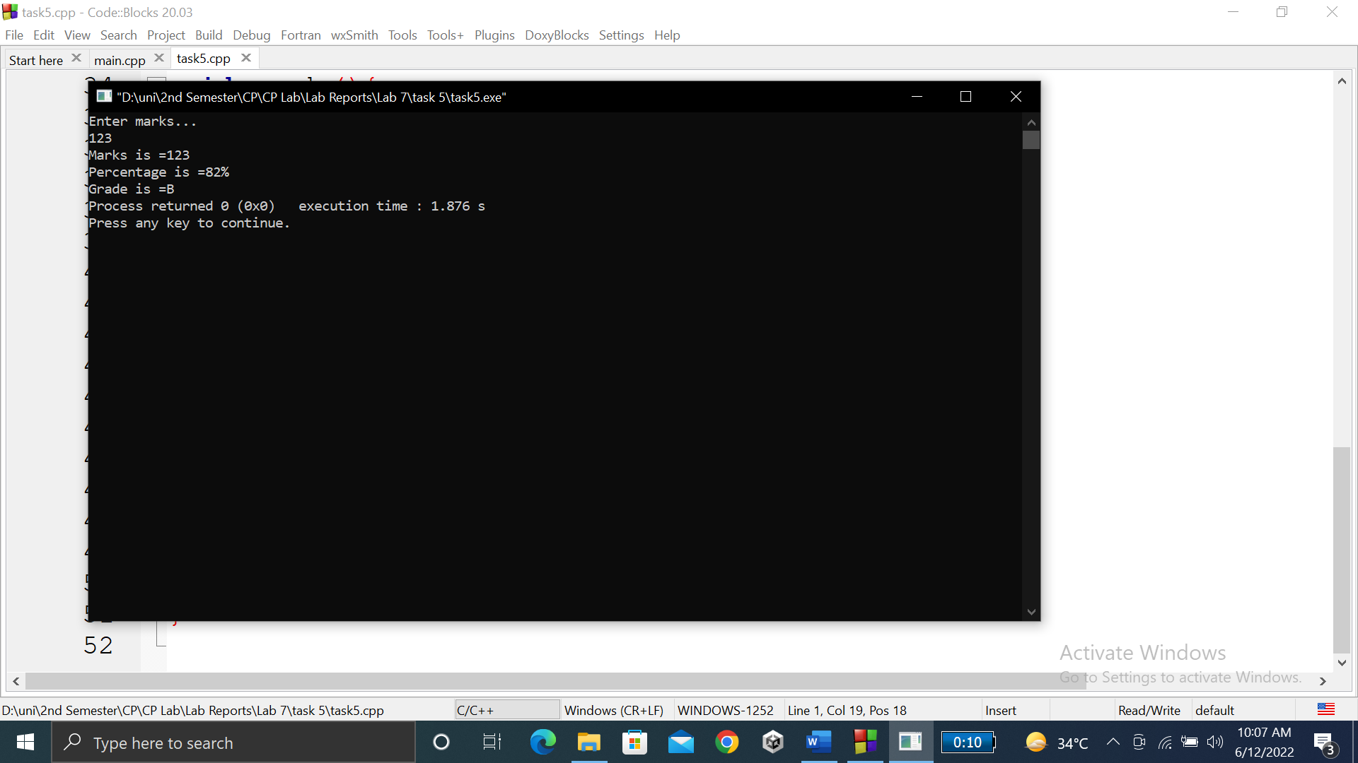

**TASK # 6:**

**Title:**

Write a C++ Program to Find Factorial of a Number Using Recursion.

**CODE SCREENSHOTS:**

Here are the screenshots of the code.

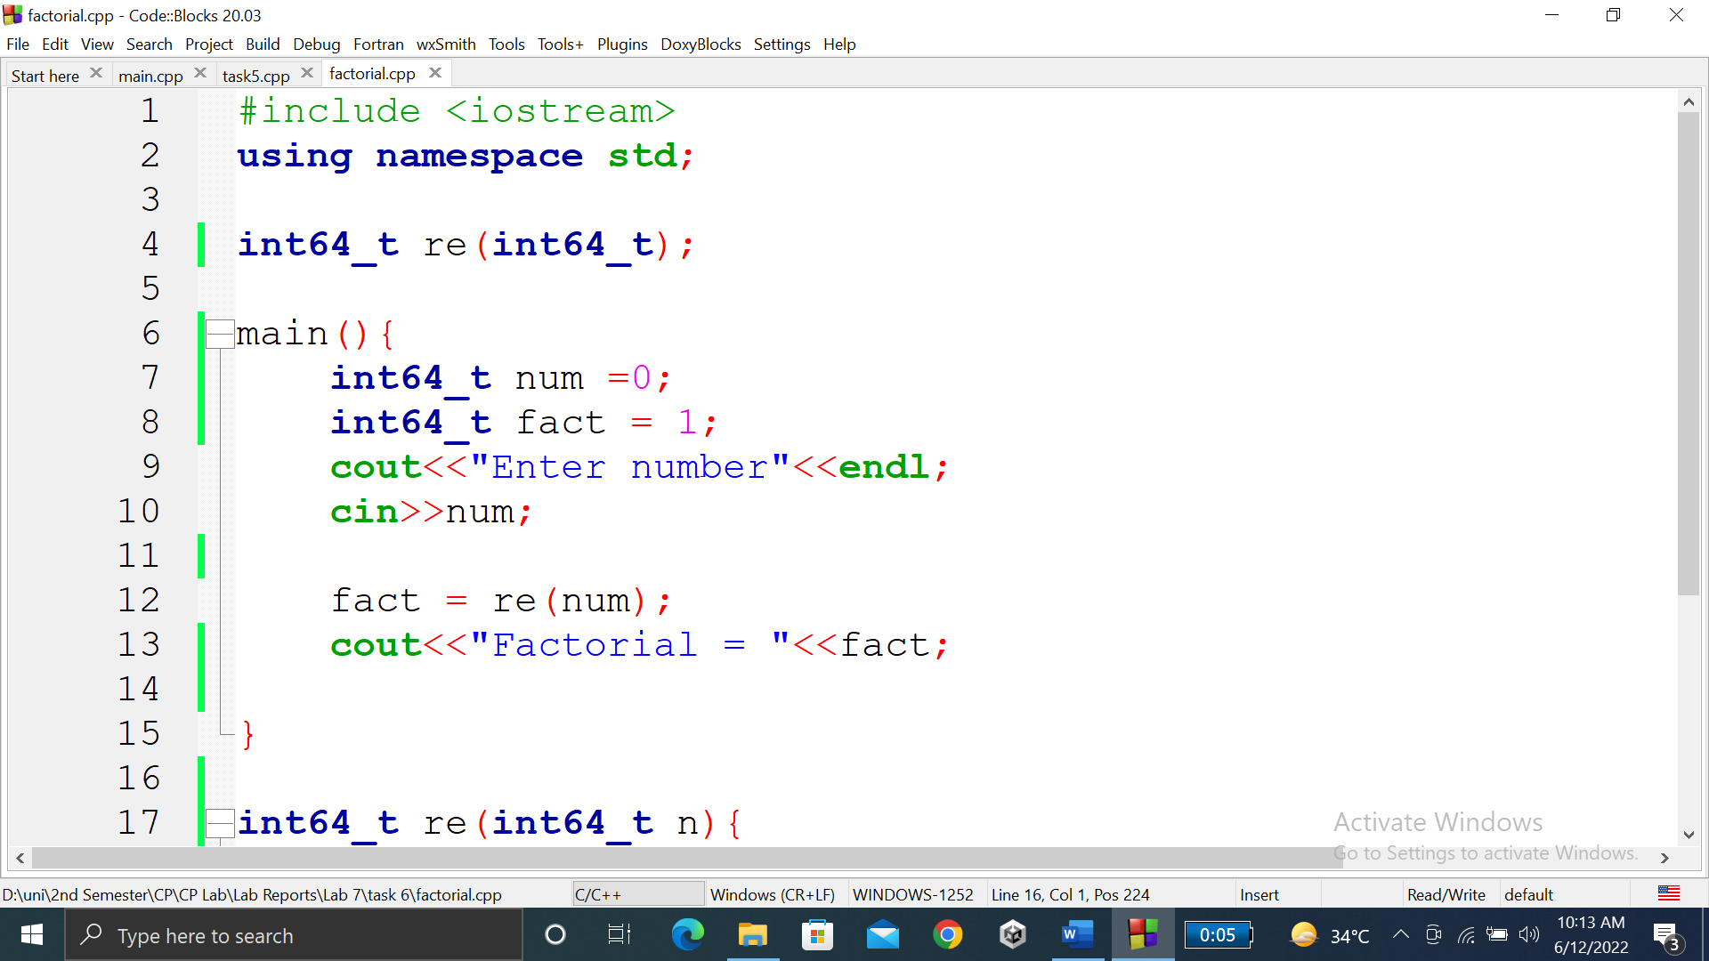

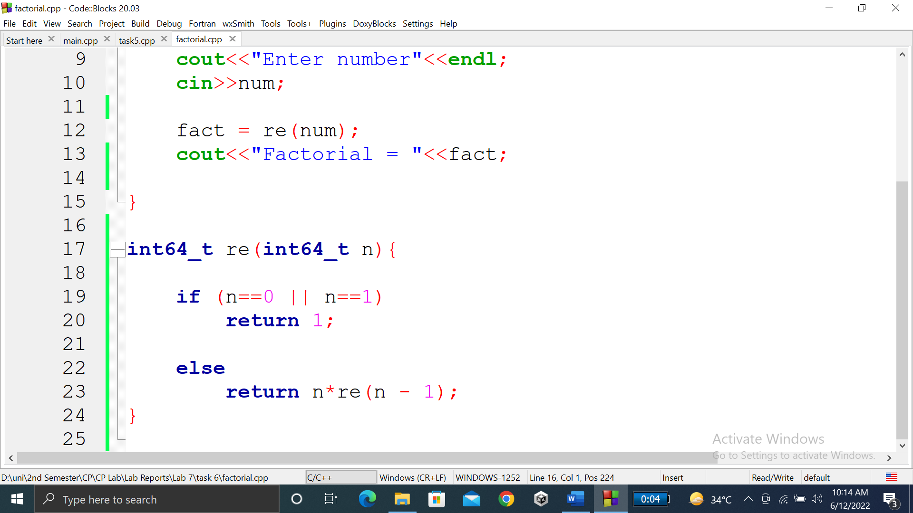

### **OUTPUT (COMPILATION, DEBUGGING & TESTING):**

Here is the screenshot of the output of above code.

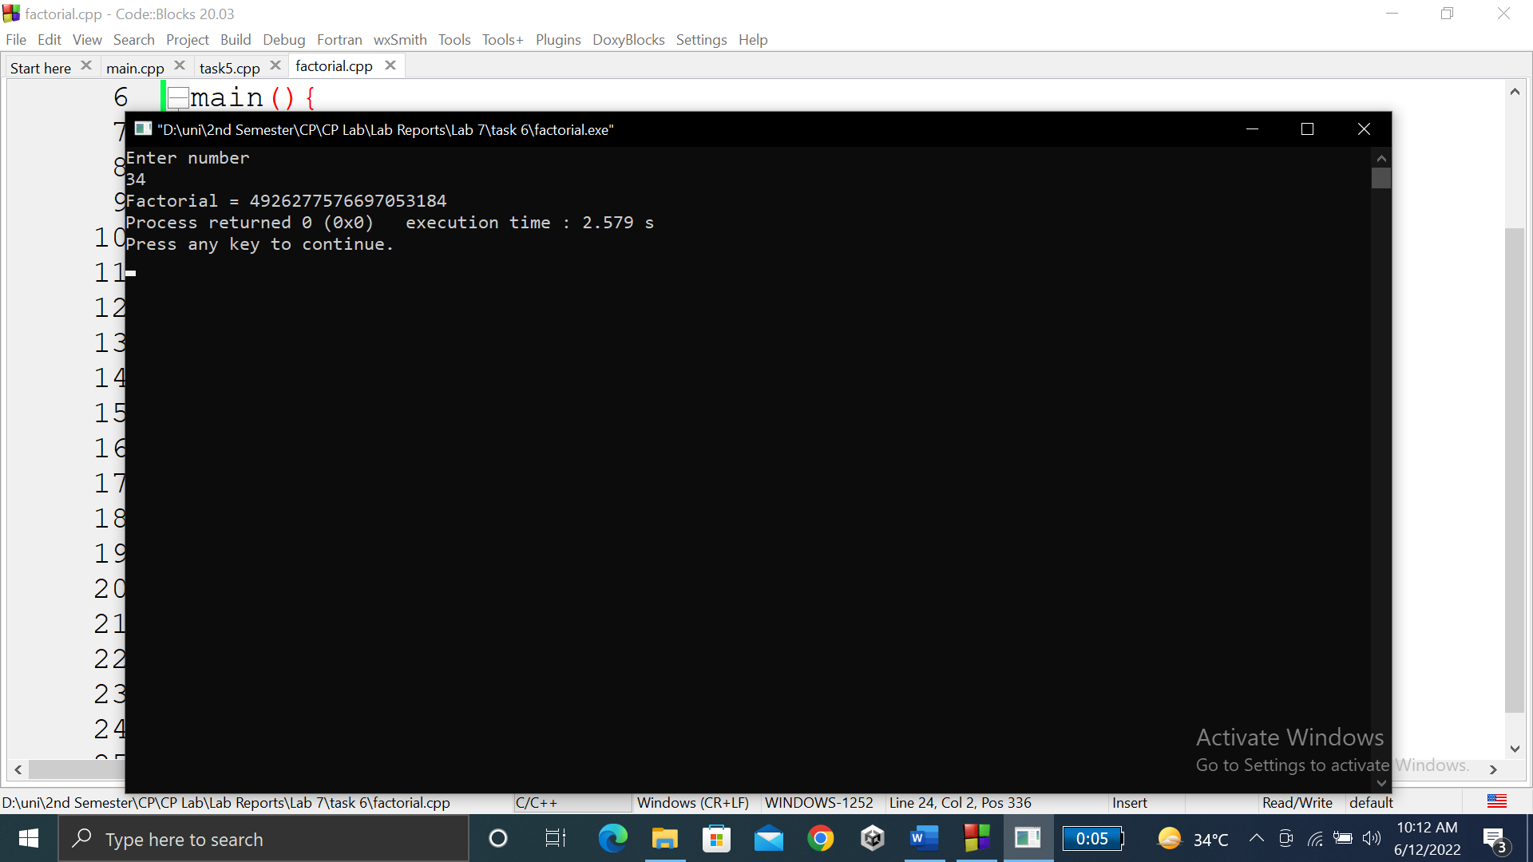

**TASK # 7:**

**Title:**

C++ program to print Fibonacci series using recursion.

**CODE SCREENSHOTS:**

Here are the screenshots of the code.

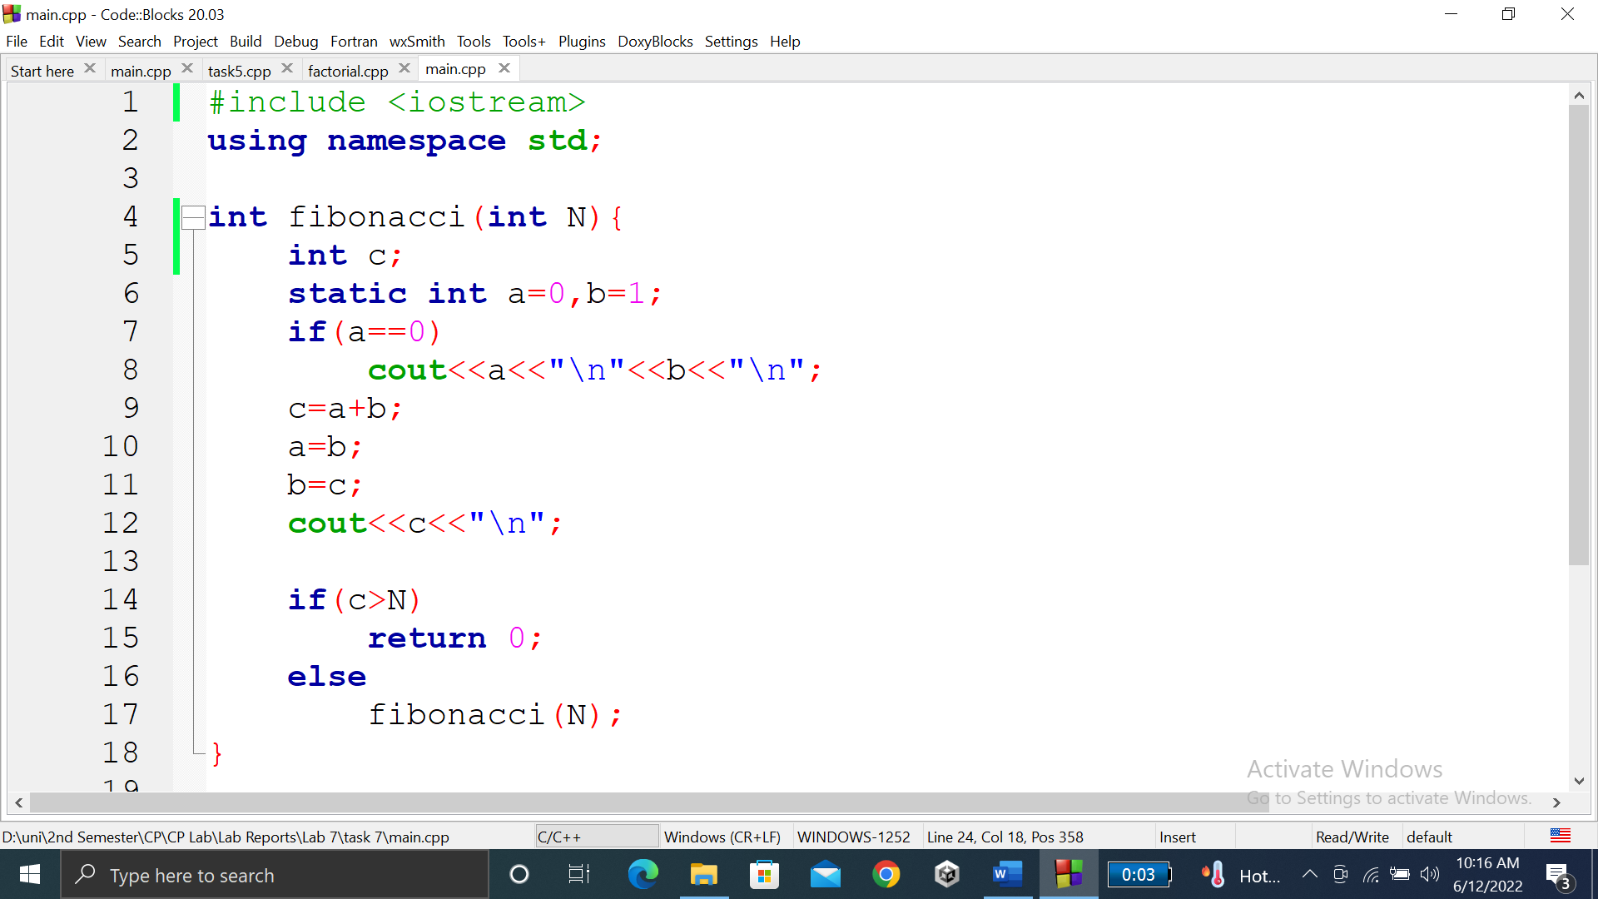

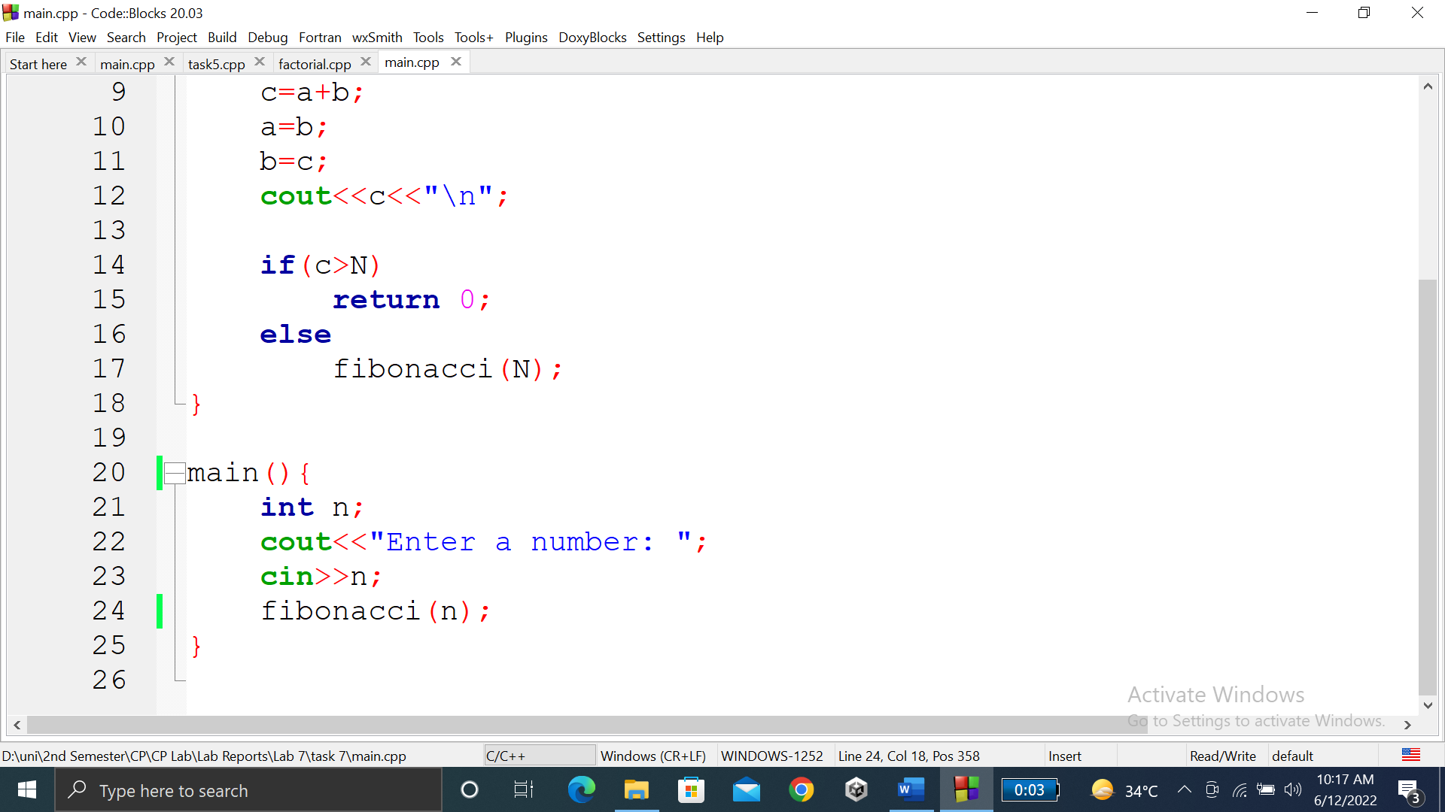

### **OUTPUT (COMPILATION, DEBUGGING & TESTING):**

Here is the screenshot of the output of above code.

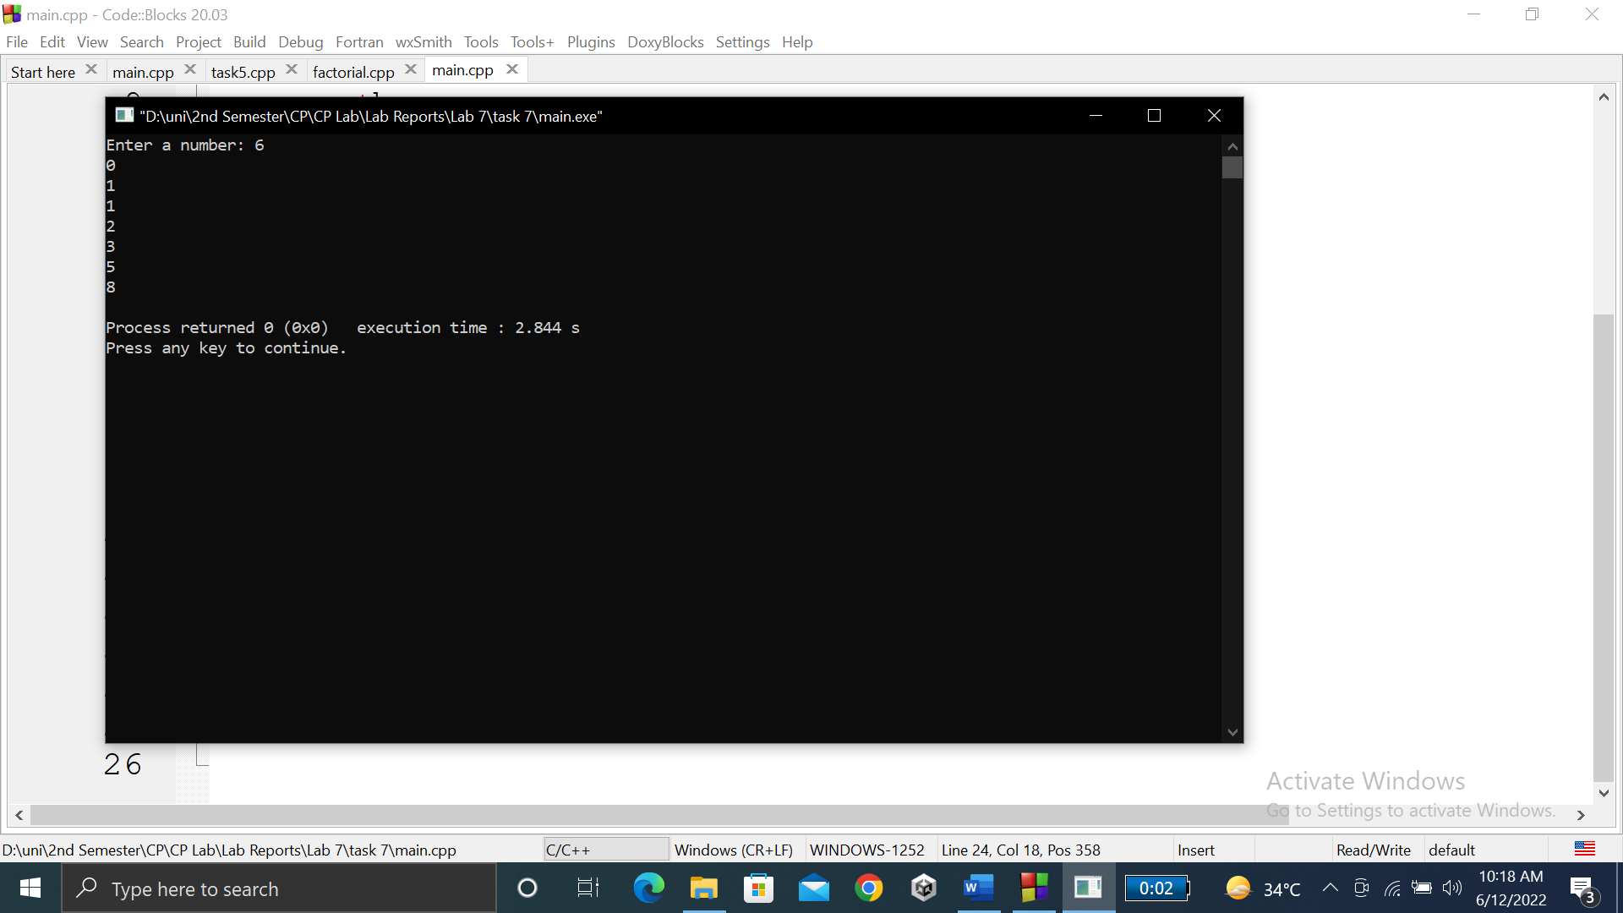

**TASK # 8:**

**Title:**

C++ program to calculate power of a number using recursion.

**CODE SCREENSHOTS:**

Here are the screenshots of the code.

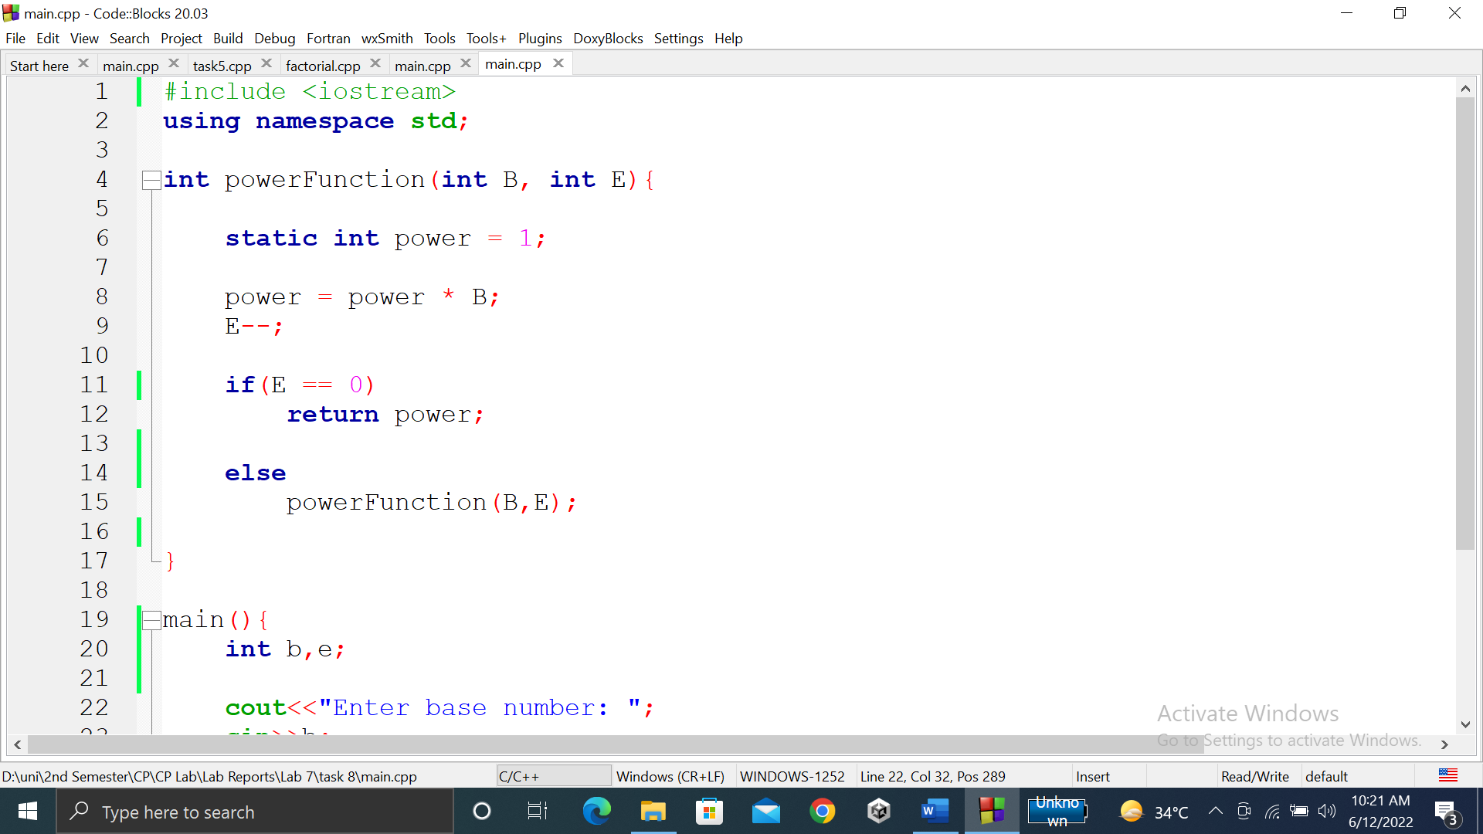

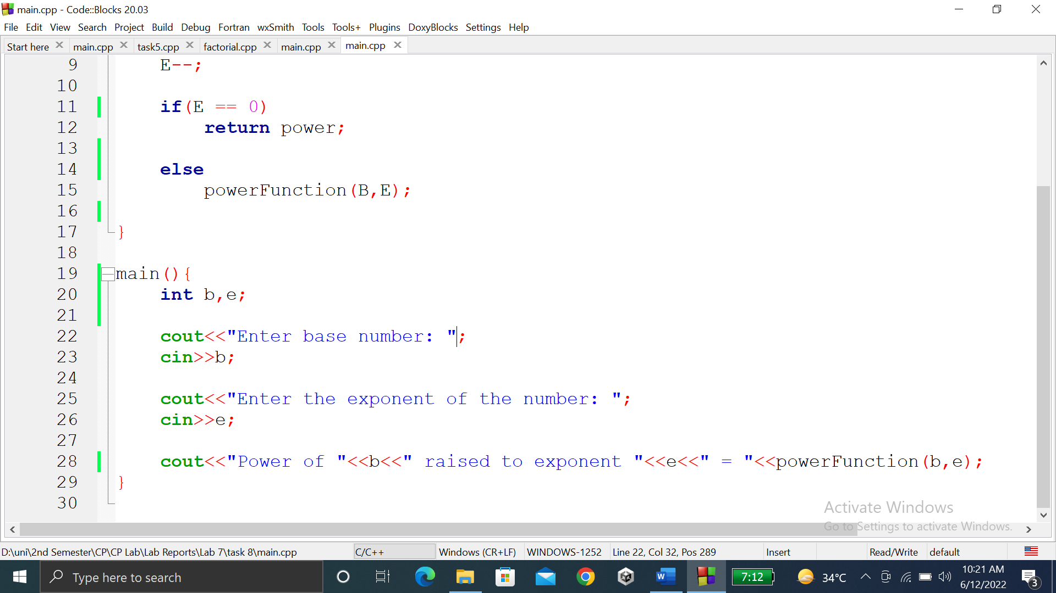

### **OUTPUT (COMPILATION, DEBUGGING & TESTING):**

Here is the screenshot of the output of above code.

